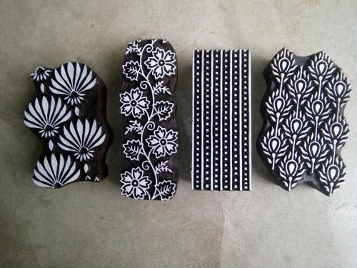

Global Public School is organizing a WINTER Camp

From 23/12/19 to 03/01/20

Open to students between age Group: 6 to 16 only

Cultural
1. Dance
2. Music
3. Art & Painting
4. Flameless cooking

Games
1. Basketball
2. Cricket
3. Badminton

Dear Team GPS,
My ward _________________________________ (name of participant) would like to join the Summer Camp organized by you and is interested in joining ___________________________event.
Parent’s Sign. _____________________

Participation Fee-300/- Per Event
(Max. 2 Events only)
Time- 09:30 am-12:30 pm

………………………………………………………………………………………………………………………

Dear Team GPS,
My ward _________________________________ (name of participant) would like to join the Winter Camp organized by you and is interested in joining 1._________________________2. ___________________event.
Parent’s Sign. _____________________
Dear Team GPS,
My ward _________________________________ (name of participant) would like to join the Summer Camp organized by you and is interested in joining ___________________________event.
Parent’s Sign. _____________________
Dear Team GPS,
My ward _________________________________ (name of participant) would like to join the Summer Camp organized by you and is interested in joining ___________________________event.
Parent’s Sign. _____________________

